|  |
| --- |
| Disaster Recovery – Customer Runbook Template |
|  |
| Run Book Reviewed and Updated  Month/Year |

Contents

Objective 2

Recovery Types 2

Zerto Deployment information 4

Zerto Network Requirements 4

Client Information 5

vCenter/vCD Server Details 5

Zerto Virtual Manager Configuration and Deployment 5

ZVM Site Settings 6

Paired ZVM Information 6

Zerto Throttling 7

VRA Information 7

VPGs and Protected VMs 7

Accessing Recovery Tools 8

Network access 8

Zerto Access 8

Key Personnel Contact Information 8

Application Recovery Plans 10

VPG Failover Order 10

VPG #1 – Change me 10

Procedure for Failover of <VPG NAME> to Recovery Site 11

VPG #2 – Change me 13

Procedure for Failover of <VPG NAME> to Recovery Site 14

VPG #3 – Change me 15

Procedure for Failover of <VPG NAME> to Recovery Site 16

Troubleshooting and Support 19

Instructions

Throughout this guide you will find areas of information that will be highlighted, much like this section, to indicate that this information should be changed to reflect your environment/company. If the information does not apply, it can be removed from the Run book completely. Likewise, you can build extra sections that directly apply to your company protocols or infrastructure. Once you have completed this book you can also delete this section as well.

After updating this runbook make sure to regenerate the Contents Index on the next page to reflect any changes that have been made. To do this, simply click within the contents box and view the menu toward the upper left corner. An update table button will appear. Click Update Tables, then select update all, and click OK.

Objective

The objective of this document is to help the recovery of business-critical applications during the event of a service interruption. This “fill-in-the-blanks” guide is to help streamline disaster recovery events so that the business suffers minimal downtown and minimal loss of data.

To achieve this objective, this guide will provide a step-by-step run book for executing disaster recovery actions leveraging Zerto Virtual Replication. It will lay out what events will justify executing a failover action, what people should be involved and notified when such actions take place, as well as lay out the additional processes and steps that need to be taken alongside the Zerto operations.

Recovery Types

Zerto provides several types of recovery methods and it is important to familiarize oneself with each. This will help to ensure that the proper recovery actions are not only understood, but also correctly executed during the event of an outage.

Move - If there can be a proactive response to a known threat Zerto offers a Move VPG function to migrate a workload to a recovery site prior to a service interruption (I.E. maintenance outages). If, however an event has already occurred then there are still two more ways to recover.

Live Failover – If an event has occurred and there is reason to believe that the production system will be out of service for a lengthy period of time, a Live Failover operation is the proper action to take. This will cause Zerto to bring that application online at the recovery site.

Journal File Level Recovery – If applications are still online, but a file(s) or folder(s) have been corrupted, then Zerto’s File Level Recovery function would be the proper solution. This allows for file level recovery at a granular level (journal checkpoints) to a time just before the corruption, while preventing the necessity of failing over the entire VM to a point-in-time.

Test Failover – This function of Zerto is for testing the recoverability of an application. It should not be used during a real event as it isn’t designed to initiate a reverse replication operation. Testing frequently and often is recommended.

LTR/Backup – If the known VM corruption or problem occurred outside of the length of the VPG’s journal retention, then Zerto’s LTR/Backup is the correct recovery solution. CSP – DEPENDING ON THE SERVICES OFFERED, YOU MAY DESIRE TO REMOVE THIS. IT WILL REQUIRE THAT THE CUSTOMER HAS A REPOSITORY IN ORDER TO BE LEVERAGED

If you would like to learn more about Zerto and its full capabilities, all documentation is publicly displayed at the following online location:

<https://www.zerto.com/myzerto/technical-documentation/>

If you are planning on upgrading your IT infrastructure, it is strongly recommended that you contact your Cloud Provider prior to any upgrades and address our interoperability matrix:

<http://s3.amazonaws.com/zertodownload_docs/Latest/Zerto%20Virtual%20Replication%20Operability%20Matrix.pdf>

Zerto Deployment information

Zerto Network Requirements

Site-to-site networking:

See *VPN Worksheet* – This is in place in case your Customer-CSP VPN has any specifics that need to be acknowledged.

Zerto Port Requirements for MSP Environments (# represents the item on the following diagrams):

|  |  |  |
| --- | --- | --- |
| Port | # | Purpose |
| 22 | **9, 24** | During Virtual Replication Appliance (VRA) installation on ESXi 4.x and 5.x hosts for  communication between the Zerto Virtual Manager (ZVM) and the ESXi hosts IPs and  for ongoing communication between the ZVM in the cloud site – but not the customer  site – and a Zerto Cloud Connector. |
| 443 | **2, 6, 8, 19** | During VRA installation on ESX/ESXi hosts for communication between the ZVM and  the ESX/ESXi hosts IPs and for ongoing communication between the ZVM and vCenter  Server and vCloud Director. |
| 4005 | **10** | Log collection between the ZVM and site VRAs. |
| 4006 | **11** | TCP communication between the ZVM and local site VRAs and the site VBA. |
| 4007 | **16, 21** | TCP control communication between protecting and peer VRAs. |
| 4008 | **17, 25** | TCP communication between VRAs to pass data from protected virtual machines to a VRA on a recovery site. |
| 4009 | **12** | TCP communication between the ZVM and local site VRAs to handle checkpoints. |
| 5672 | **20** | TCP communication between the ZVM and vCloud Director for access to AMQP messaging. |
| 7073 |  | Internal port, used only on the ZVM VM. Used for communication with the service in charge of collecting data for the Zerto Resource Planner.  **Note :** Unless you select the checkbox ‘Enable Support notification and product improvement feedback’, data is not transmitted to Zerto Analytics. |
| 8100 | **-** | Communication between the Zerto Virtual Manager and the System Center Virtual Machine Manager in a customer site running Zerto Virtual Replication with Hyper-V. |
| 9007 | **-** | VRA to VRA Encryption is disabled by default. Upon enabling this feature within “Site Settings > Policies”, VRA commmunications are secured and encrypted via TLS over TCP. |
| 9008 | **-** | VRA to VRA Encryption is disabled by default. Upon enabling this feature within “Site Settings > Policies”, VRA commmunications are secured and encrypted via TLS over TCP. |
| 9071* |  | HTTPS communication between paired ZVMs, when both Zerto versions are 8.0 and above. |
| 9080* | **1, 13, 15, 18** | • HTTP communication between the ZVM and Zerto internal APIs, a Zerto Cloud  Manager (ZCM), cmdlets, which should only be available to a customer using  DRaaS and not ICDR.  • HTTP communication between ZVM and Zerto Cloud Manager (ZCM). When the  customer's ZCM is **v5.5 and above**, and their ZVM is **v5.0**, communication is via  this port. |
| 9081* | **7, 23, 27** | TCP communication between ZVMs and between a customer ZVM and a Zerto Cloud Connector, maintained for backward compatibility purposes.  **This port must not be changed when providing DRaaS.** |
| 9082 and up | **22, 26, 28, 29** | Two ports for each VRA (one for port 4007 and one for port 4008) accessed via the  Zerto Cloud Connector installed by the cloud service provider. There is directionality  to these ports. Use a port range starting with port 9082. For example, Customer A  network has 3 VRAs and customer B network has 2 VRAs and the cloud service  provider management network has 4 VRAs, then the following ports must be open in  the firewall for each cloud: The cloud service provider's VRAs need to use 6 ports to  reach customer A's VRAs, while customer A's VRAs need 8 ports to reach the cloud's  VRAs. The cloud service provider's VRAs need to use 4 ports to reach customer B's  VRAs, while customer B's VRAs need 8 ports to reach the cloud's VRAs |
| 9180* | **32** | Communication between the ZVM and the VBA. |
| 9669* | **3, 4, 5, 14** | HTTPS communication between:  • Machines running Zerto User Interface and Zerto Virtual Manager  • Zerto Virtual Manager and Zerto REST APIs  • ZVM and Zerto Cloud Manager (ZCM). When the customer's ZCM and ZVM are both  **v5.5 and above**, communication is via this port. |
| 9779 |  | HTTPS communication between the Zerto Self-Service Portal for in-cloud (ICDR)  customers and a ZVM. |
| 9989 |  | HTTPS communication between the browser and the Zerto Cloud Manager. |

**\*The default port provided during the ZVR installation which can be changed during the installation.**

**\*\*When the same vCenter Server is used for both the protected and recovery sites, ZVR is installed on one site only and this port can be ignored**

For the most current Zerto port requirements, please see our guideline documentation here:

<http://s3.amazonaws.com/zertodownload_docs/Latest/Zerto%20Virtual%20Replication%20vSphere%20Enterprise%20Guidelines.pdf>

Client Information

|  |  |
| --- | --- |
| Client Acronym |  |
| Domain Name |  |
| NTP Servers |  |
| Antivirus Software |  |
| Mail Server | Not used |
| Notification Email | Not used |

vCenter/vCD Server Details

|  |  |
| --- | --- |
| Host Name/IP |  |
| vCenter/vCD Version and Build |  |
| Zerto Service Administrative User |  |
| Site Name |  |
| VMware HA enabled | Not used |

Zerto Virtual Manager Configuration and Deployment

|  |  |
| --- | --- |
| ZVM Name |  |
| VM ZVM is deployed on | VM name |
| ZVM Version | 8.0u1 |
| ZVM Static IP |  |
| Gateway |  |
| DNS |  |
| Windows Server Version |  |
| Window OS Update responsibility | CSP/Customer |
| Virus scan exclusions: C:\Program Files (x86)\Zerto\Zerto Virtual Replication | Yes/No |
| vCPU | 2 |
| Memory | 4GB |
| NTP configured | Yes/No |
| Local Admin rights granted to CSP | Yes/No |
| Other applications installed on this VM | Yes/No – The answer should ALWAYS be No. This field is to help ensure that |

ZVM Site Settings

|  |  |
| --- | --- |
| Site Name |  |
| Site Location |  |
| Contact Name |  |
| Contact Email |  |
| Contact Phone |  |

Paired ZVM Information

|  |  |
| --- | --- |
| Site Name |  |
| Site Location |  |
| ZVM Paired IP |  |

Zerto Throttling

If Zerto replication does not use a dedicated network, then throttling may be required during specific application tasks or other reasons. If applicable, please fill in the details below:

|  |  |
| --- | --- |
| Throttle Timeframe | Details |
| 5AM to 8PM Su-Sa | 200Mbps |
| 8PM to 5AM Su-Sa | 250Mbps |

VRA Information

|  |  |
| --- | --- |
| VRA ESXi Host | Static IP |
|  |  |
|  |  |
|  |  |
|  |  |
|  |  |
|  |  |
|  |  |
|  |  |
|  |  |
|  |  |

VPGs and Protected VMs

|  |  |  |  |  |  |  |
| --- | --- | --- | --- | --- | --- | --- |
| VM Name | vSphere Network | IP | VM | RPO | Recovery Order (if applicable) | VPG Name |
|  |  |  |  |  |  |  |
|  |  |  |  |  |  |  |
|  |  |  |  |  |  |  |
|  |  |  |  |  |  |  |
|  |  |  |  |  |  |  |
|  |  |  |  |  |  |  |
|  |  |  |  |  |  |  |
|  |  |  |  |  |  |  |

Accessing Recovery Tools

Network access

All recovery tools will require access to the corporate network. If access to a corporate network drop is unavailable, access is available via the following methods:

|  |  |  |  |
| --- | --- | --- | --- |
| Name | Type | Details | Site |
| Boston VPN | Cisco SSL VPN | Use a browser or the Cisco SSL client and point to https://bos-vpn.mycompany.com | Boston DR Colo |
| RDP Jump Host | MS RDP | Use Microsoft RDP Client and point to 1.2.3.4 port 33389 | Chicago Warehouse |
| Zerto ZSSP | Service Portal | <https://ZVM-IP:9779>  ZORG: TEST-ZORG  User: TESTER  Password: XXXXXX | Change Me |

Zerto Access

Zerto uses a web-based console that can be accessed via any device attached to the corporate network. The following Zerto Virtual Manager interfaces are available. Use vSphere administrator credentials for login access.

|  |  |  |
| --- | --- | --- |
| Site Name | URL | Description |
| Boston | https://1.2.3.4:9669 | Boston DR Colo |
| Chicago | https://2.3.4.5:9669 | Chicago Warehouse Server Room |
| Columbus | <https://3.4.5.6:9669> | Columbus Sales Office |

Key Personnel Contact Information

CSP NAME Contact List

The following people at CSP NAME should be alerted when an event occurs.

|  |  |  |
| --- | --- | --- |
| Name and Title | Contact Method | Contact Info |
| John Doe, CIO | Office Phone | 123-456-7890 |
|  | Cell Phone | 123-456-7890 |
|  | Home Phone | 123-456-7890 |
|  | Work Email | JD@myco.com |
|  | Personal Email | [personal@hotmail.com](mailto:personal@hotmail.com) |
| John Doe, IT Director | Office Phone |  |
|  | Cell Phone |  |
|  | Home Phone |  |
|  | Work Email |  |
|  | Personal Email |  |

END-CUSTOMER NAME

The following people should be alerted internally when an event occurs.

|  |  |  |
| --- | --- | --- |
| Name and Title | Contact Method | Contact Info |
| John Doe, CIO | Office Phone | 123-456-7890 |
|  | Cell Phone | 123-456-7890 |
|  | Home Phone | 123-456-7890 |
|  | Work Email | JD@myco.com |
|  | Personal Email | [personal@hotmail.com](mailto:personal@hotmail.com) |
| John Doe, IT Director | Office Phone |  |
|  | Cell Phone |  |
|  | Home Phone |  |
|  | Work Email |  |
|  | Personal Email |  |

Application Recovery Plans

The following pages can be copied and pasted as many times as needed depending on the number of applications (VPG’s) that need to be planned for. Remember to update the Contents table at the beginning of this document to reflect new sections.

If a complete workload failover is needed, then all of the following VPG’s should be failed over in the order in which they appear below. If a single VPG needs to be failed over, then you can skip to that specific VPG section.

VPG Failover Order

1. <VPG #1>
2. <VPG #2>
3. <VPG #3>
4. <VPG #4>
5. <VPG #5>

VPG #1 – Change me

|  |  |  |  |
| --- | --- | --- | --- |
| Application Owner Information | | | |
| Department | Accounting |  | |
| RTO SLA | 1 Hour |
| Primary Contact | John Doe | **Phone** | 123-456-7890 |
|  |  | **Email** | john@myco.com |
| Secondary Contact | Jane Doe | **Phone** | 123-456-7890 |
|  |  | **Email** | jane@myco.com |

|  |
| --- |
| Overview of services provided by this application |
| Text about the services that are provided by this application and what happens when this application is offline. |

|  |
| --- |
| What events justify a failover of this application |
| Describe the business impact that this application has on profits when it is offline and what does and what does not qualify this application to be failed over. It should be in simple terms so that anyone can make an educated decision. |

|  |
| --- |
| Important Information to remember when failing over this application |
| Include any notes on what applications to check on the servers once they are online at the recovery site. Also include any tips and tricks that may be needed to recover the applications that may not be obvious to someone who doesn’t work with them on a day to day basis. |

Procedure for Failover of <VPG NAME> to Recovery Site

1. In the Zerto User Interface set the operation to LIVE and click FAILOVER.  
   The Failover Wizard is displayed.  
   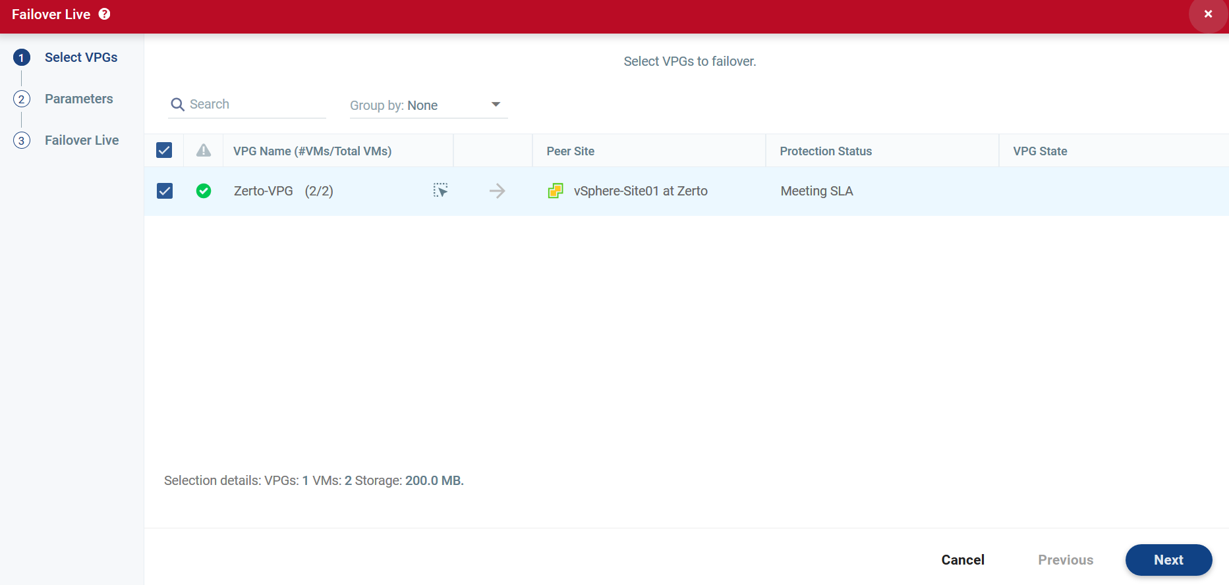   
     
   Notes: <Insert any notes you need to here… .for example if this VPG needs to be failed over before or after another VPG>
2. In the Failover wizard, Select the <Application Name Here> VPG.
3. Click Next to review the failover settings, verify that the proper Checkpoint has been selected.  
   The Commit Policy should be set to <Auto-Commit, 10 minutes>, and the Reverse Protection should be unchecked at this time.  
   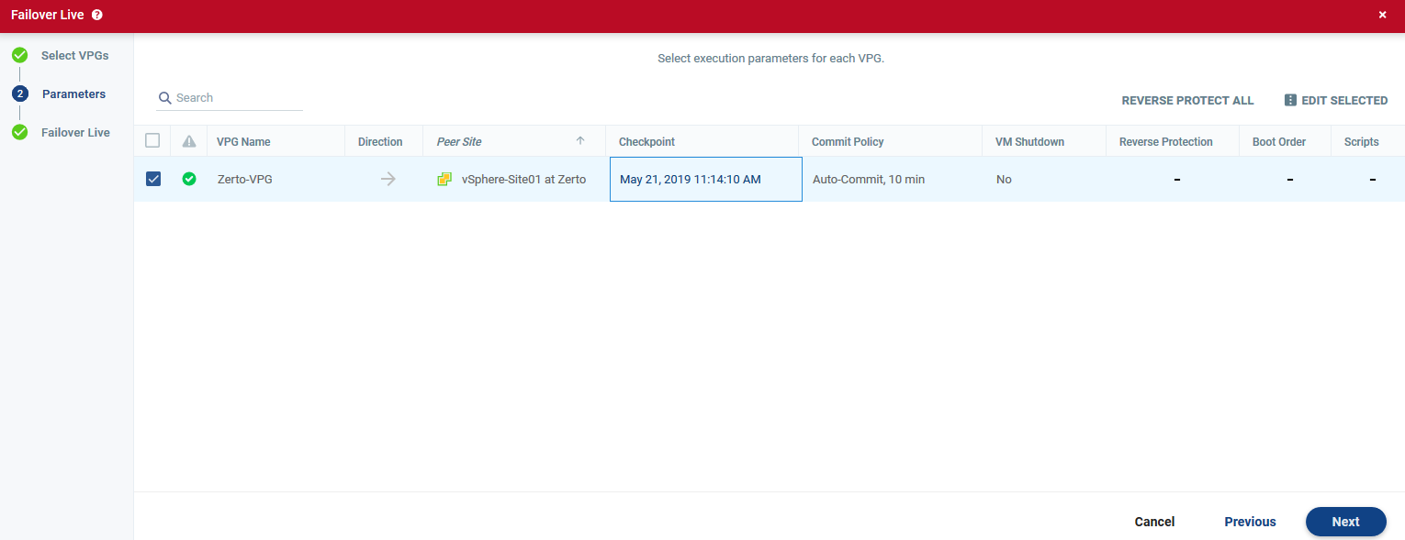
4. Click Next to advance to the Start Failover section of the wizard. On this page click START FAILOVER to initiate the transition of the application to the recovery site.  
   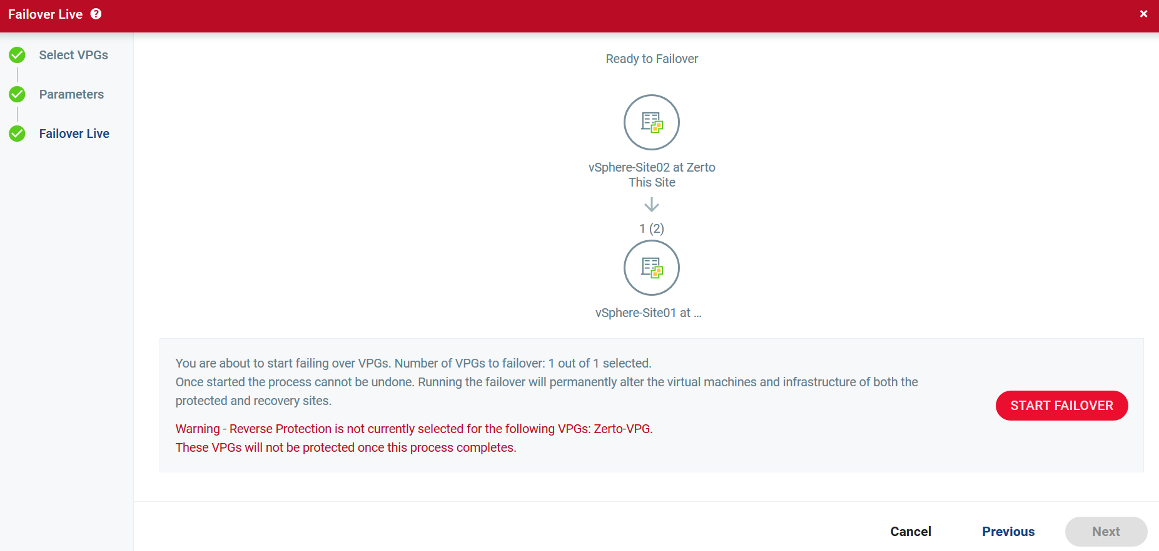
5. Once the Application has been verified to be working you can return to the Zerto User Interface to Commit the failover, or after 10 minutes the failover will be automatically committed.
6. At this point the application should be up and running and Zerto should show the VPG in a “needs configuration” state. This is normal until reverse replication has been configured. Contact Zerto Technical Support to initiate the reverse replication and verify that things are working properly.

VPG #2 – Change me

|  |  |  |  |
| --- | --- | --- | --- |
| Application Owner Information | | | |
| Department | Accounting |  | |
| RTO SLA | 1 Hour |
| Primary Contact | John Doe | **Phone** | 123-456-7890 |
|  |  | **Email** | john@myco.com |
| Secondary Contact | Jane Doe | **Phone** | 123-456-7890 |
|  |  | **Email** | jane@myco.com |

|  |
| --- |
| Overview of services provided by this application |
| Text about the services that are provided by this application and what happens when this application is offline. |

|  |
| --- |
| What events justify a failover of this application |
| Describe the business impact that this application has on profits when it is offline and what does and what does not qualify this application to be failed over. It should be in simple terms so that anyone can make an educated decision. |

|  |
| --- |
| Important Information to remember when failing over this application |
| Include any notes on what applications to check on the servers once they are online at the recovery site. Also include any tips and tricks that may be needed to recover the applications that may not be obvious to someone who doesn’t work with them on a day to day basis. |

Procedure for Failover of <VPG NAME> to Recovery Site

1. In the Zerto User Interface set the operation to LIVE and click FAILOVER.  
   The Failover Wizard is displayed.  
      
     
   Notes: <Insert any notes you need to here… .for example if this VPG needs to be failed over before or after another VPG>
2. In the Failover wizard, Select the <Application Name Here> VPG.
3. Click Next to review the failover settings, verify that the proper Checkpoint has been selected.  
   The Commit Policy should be set to <Auto-Commit, 10 minutes>, and the Reverse Protection should be unchecked at this time.  
   
4. Click Next to advance to the Start Failover section of the wizard. On this page click START FAILOVER to initiate the transition of the application to the recovery site.  
   
5. Once the Application has been verified to be working you can return to the Zerto User Interface to Commit the failover, or after 10 minutes the failover will be automatically committed.
6. At this point the application should be up and running and Zerto should show the VPG in a “needs configuration” state. This is normal until reverse replication has been configured. Contact Zerto Technical Support to initiate the reverse replication and verify that things are working properly.

VPG #3 – Change me

|  |  |  |  |
| --- | --- | --- | --- |
| Application Owner Information | | | |
| Department | Accounting |  | |
| RTO SLA | 1 Hour |
| Primary Contact | John Doe | **Phone** | 123-456-7890 |
|  |  | **Email** | john@myco.com |
| Secondary Contact | Jane Doe | **Phone** | 123-456-7890 |
|  |  | **Email** | jane@myco.com |

|  |
| --- |
| Overview of services provided by this application |
| Text about the services that are provided by this application and what happens when this application is offline. |

|  |
| --- |
| What events justify a failover of this application |
| Describe the business impact that this application has on profits when it is offline and what does and what does not qualify this application to be failed over. It should be in simple terms so that anyone can make an educated decision. |

|  |
| --- |
| Important Information to remember when failing over this application |
| Include any notes on what applications to check on the servers once they are online at the recovery site. Also include any tips and tricks that may be needed to recover the applications that may not be obvious to someone who doesn’t work with them on a day to day basis. |

Procedure for Failover of <VPG NAME> to Recovery Site

1. In the Zerto User Interface set the operation to LIVE and click FAILOVER.  
   The Failover Wizard is displayed.  
      
     
   Notes: <Insert any notes you need to here… .for example if this VPG needs to be failed over before or after another VPG>
2. In the Failover wizard, Select the <Application Name Here> VPG.
3. Click Next to review the failover settings, verify that the proper Checkpoint has been selected.  
   The Commit Policy should be set to <Auto-Commit, 10 minutes>, and the Reverse Protection should be unchecked at this time.  
   
4. Click Next to advance to the Start Failover section of the wizard. On this page click START FAILOVER to initiate the transition of the application to the recovery site.  
   
5. Once the Application has been verified to be working you can return to the Zerto User Interface to Commit the failover, or after 10 minutes the failover will be automatically committed.
6. At this point the application should be up and running and Zerto should show the VPG in a “needs configuration” state. This is normal until reverse replication has been configured. Contact Zerto Technical Support to initiate the reverse replication and verify that things are working properly.

Troubleshooting and Support

CSP NAME will always be the first point of contact for any issues or problems that occur within Zerto. As a CSP NAME customer, never attempt to contact Zerto Support directly for any Zerto related issues. CSP NAME will always perform the initial troubleshooting steps, as the issue may be already be known by CSP NAME or within their infrastructure.

Cloud Provider Support Contacts

|  |  |  |
| --- | --- | --- |
| Name and Title | Contact Method | Contact Info |
| John Doe, CIO | Office Phone | 123-456-7890 |
|  | Cell Phone | 123-456-7890 |
|  | Home Phone | 123-456-7890 |
|  | Work Email | JD@myco.com |
|  | Personal Email | [personal@hotmail.com](mailto:personal@hotmail.com) |
| John Doe, IT Director | Office Phone |  |
|  | Cell Phone |  |
|  | Home Phone |  |
|  | Work Email |  |
|  | Personal Email |  |